
Implementation Manual

Implementation Manual
The implementation manual contains the system configuration recommended to conduct the course. It also includes the steps to install Microsoft SQL Server 2005 Standard Edition.

Recommended System Configuration
The following table lists the recommended system configuration for the MR and CR sessions.

# | TYPE | MR | CR
1 | Number of Machines
1.1 | Faculty Node | 1 | 1
1.2 | Student Nodes | <Depends on the machine room setup> | <Depends on the class room setup>
2 | H/w Configuration
2.1 | Faculty Node | A node with PIII processor (800 MHz or higher), SCSI Hard disk of 20GB, 512MB RAM, CDROM and 2-10/100 Mbps network cards.  VGA: 800x600 or higher | A node with PIII processor (800 MHz or higher), SCSI Hard disk of 20GB, 512MB RAM, CDROM and  2-10/100 Mbps network cards.  VGA: 800x600 or higher
2.2 | Student Nodes | A node with PIII processor (800 MHz or higher), SCSI Hard disk of 20GB, 256MB RAM, CDROM and 1-10/100 Mbps network card. | A node with PIII processor (800 MHz or higher), SCSI Hard disk of 20GB, 256MB RAM, CDROM and  1-10/100 Mbps network card.
2.3 | Printer | NA | NA
3 | S/w Configuration
3.1 | Faculty Node | Windows 2003 Server with SP1, SQL Server 2005 Standard Edition (Client Components), Flash Player for running Flash presentations | Windows 2003 Server with SP1, SQL Server 2005 Standard Edition (Client Components), Flash Player for running Flash presentations
3.3 | Student Nodes | Windows XP with SP 2, SQL Server 2005 Standard Edition (Client Components) ), Flash Player for running Flash presentations

Recommended System Configuration
Note


You need to install the SQL Server at the server in the Server Room. To demonstrate the activities, you will connect to this server from the Class Room.

Installing SQL Server 2005

- Insert the SQL Server Installation CD in the CD drive to start the Microsoft SQL Server 2005 Setup wizard.
- In the SQL Server 2005 (Disc 1 of 2) screen, click the Server components, tools, Books Online, and samples link under the Install section, as shown in the following figure.
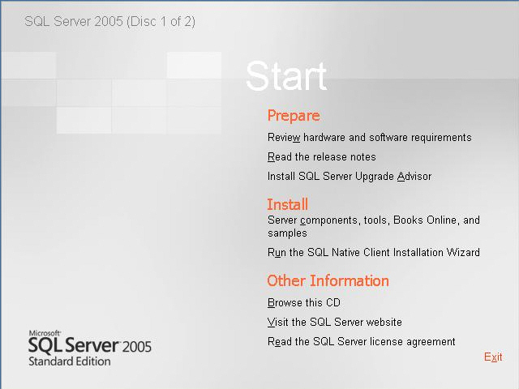
SQL Server 2005 (Disc 1 of 2) Screen
The End User License Agreement screen is displayed.

- Select the I accept the licensing terms and conditions check box in the End User License Agreement screen, as shown in the following figure.
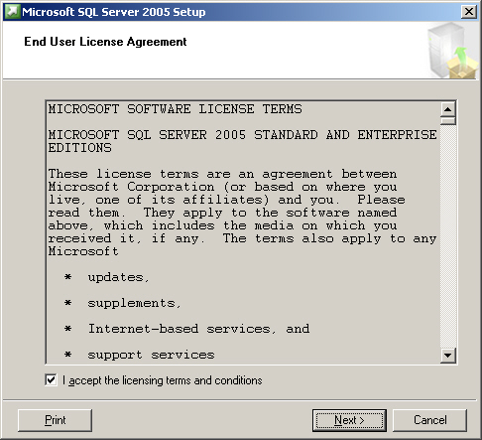
End User License Agreement Screen
- Click the Next button to display the Installing Prerequisites screen, as shown in the following figure.
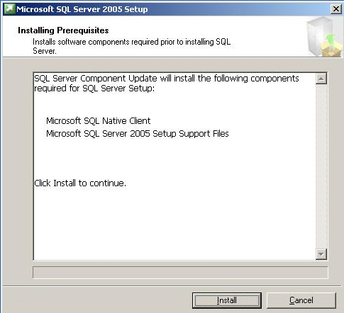
Installing Prerequisites screen
- Click the Install button. When the required components are successfully installed, the Installing Prerequisites screen will appear, as shown in the following figure.
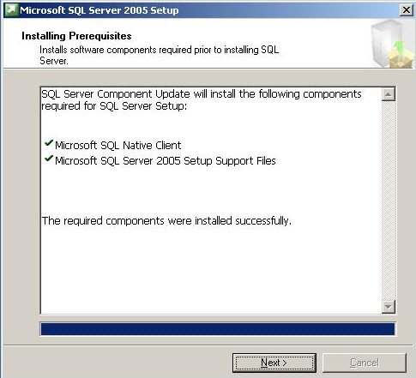
Installing Prerequisites Screen

Note

Prerequisites may differ from machine to machine.

- Click the Next button to display the Welcome to the Microsoft SQL Server Installation Wizard screen, as shown in the following figure.
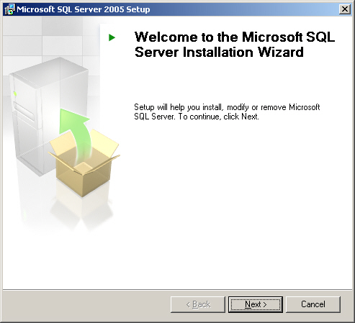
Welcome Screen
- Click the Next button to continue.
- After the components are installed/updated on the machine, the SQL Server 2005 setup will show the System Configuration Check screen, as shown in the following figure.
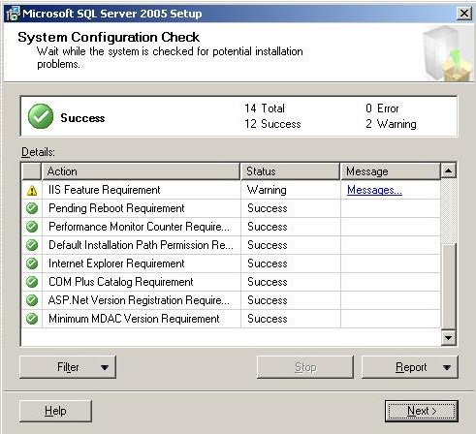
System Configuration Check Screen
Note
You can select the Filter button to see selected results, such as errors or warnings. Selecting the Report button will display a report of the System Configuration Check.

- Click the Next button to display the Registration Information screen. Type the name in the Name text box and the company’s name in the Company text box. In addition, you need to type the product key in the five text boxes available to enter the product key.
- Click the Next button. The Components to Install screen will appear, as shown in the following figure.
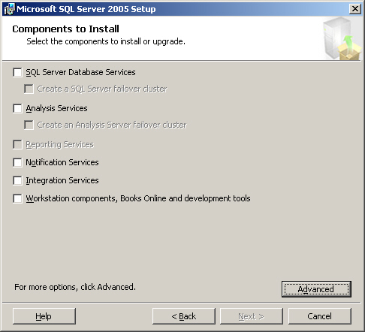
Components to Install Screen
- Click the Advanced button to display the Feature Selection screen. Select the Entire feature will be installed on local hard drive option from the Database Services node. Do the same for all the nodes and sub-nodes available in the list, as shown in the following figure.
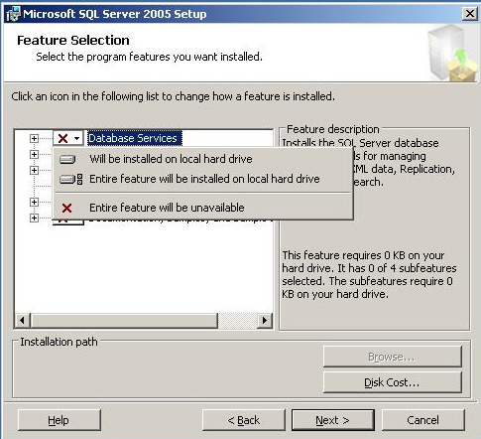
Feature Selection Screen
- Click the Next button to display the Instance Name screen. Ensure that the Default instance option is selected, as shown in the following figure.
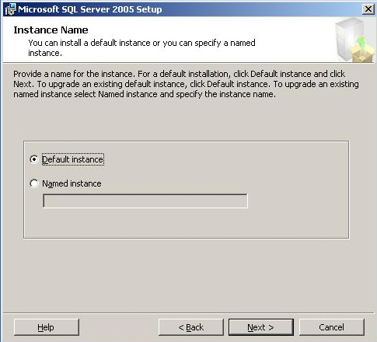
Instance Name Screen

Note

Ensure that you install a default instance of SQL Server2005. For this, you might need to uninstall previous instances of SQL Server 2000, if they exist and re-install.

- Click the Next button to display the Service Account screen. Select the Use the built-in System account option and ensure that the Local system option is selected from the drop-down list box, as shown in the following figure.
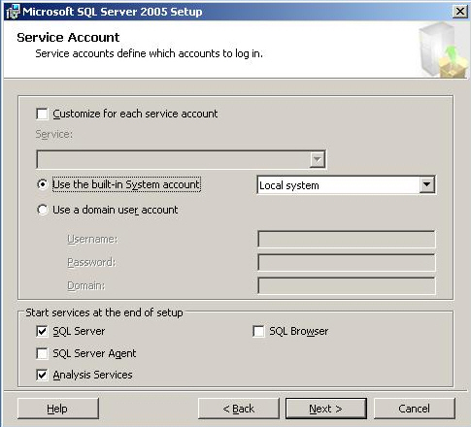
Service Account Screen
- Click the Next button to display the Authentication Mode screen. Select the Mixed Mode (Windows Authentication and SQL Server Authentication) option and type the password for sa in the Enter password text box. In addition, confirm the password by entering the same password in the Confirm password text box.

- Click the Next button to display the Collation Settings screen. Select the desired settings (default preferred), as shown in the following figure.
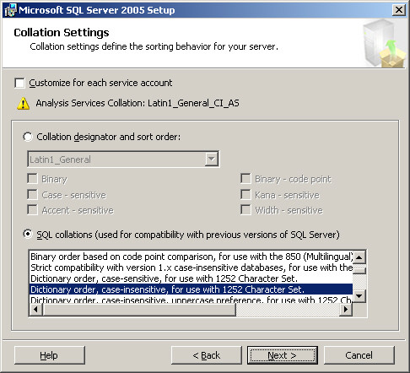
Collation Settings Screen

- Click the Next button to display the Error and Usage Report Settings screen, as shown in the following figure.
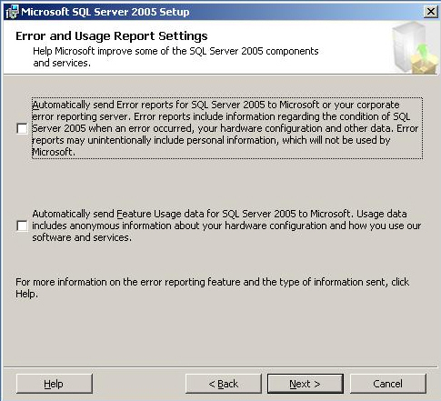
Error and Usage Report Settings Screen
- Click the Next button to display the Ready to Install screen, as shown in the following figure.
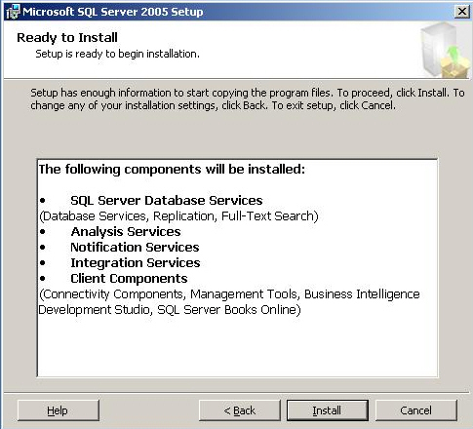
Ready to Install Screen
- Click the Install button to display the Setup Progress screen.
- The setup installs the components in the Setup Progress screen, as shown in the following figure.
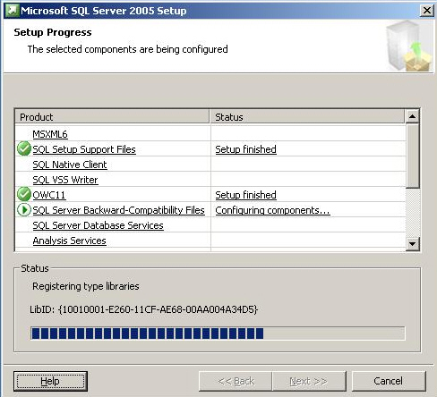
The Setup Progress Screen
Note
During the installation of the components, a message box prompting to insert CD2 will appear. Insert the CD 2 of 2 and click the OK button to continue.

- Click the Next button after the setup finishes installing all the components. The Completing Microsoft SQL Server 2005 Setup screen appears, as shown in the following figure.
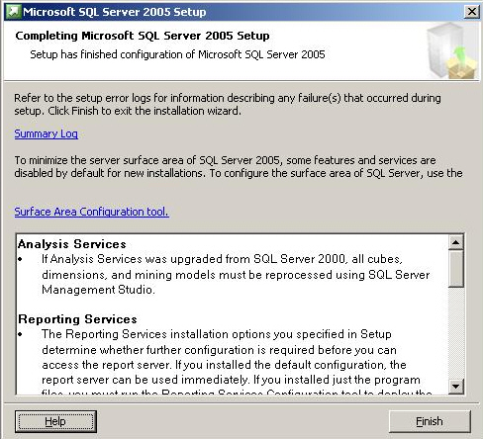
Completing Microsoft SQL Server 2005 Setup Screen
- Click the Finish button to complete the installation.

Creating Users on SQL Server 2005
For the activities, you need to create the following users on SQL Server:

S. No. | User Name | Rights
1 | Kim | dbreader, dbwriter, ddladmin
2 | Angela | dbreader, dbwriter, ddladmin
3 | Robert | dbreader, dbwriter, ddladmin
To create the logins and users, you need to execute the following statements:

CREATE LOGIN Kim
WITH PASSWORD = 'password',
DEFAULT_DATABASE = AdventureWorks

CREATE LOGIN Angela
WITH PASSWORD = 'password',
DEFAULT_DATABASE = AdventureWorks

CREATE LOGIN Robert
WITH PASSWORD = 'password',
DEFAULT_DATABASE = AdventureWorks

GO

USE AdventureWorks
GO
CREATE USER Kim
FOR LOGIN Kim

CREATE USER Robert
FOR LOGIN Robert

CREATE USER Angela
FOR LOGIN Angela
GO

exec sp_addrolemember 'db_datareader','Robert'
exec sp_addrolemember 'db_datawriter','Robert'
exec sp_addrolemember 'db_ddladmin','Robert'
exec sp_addrolemember 'db_datareader','Kim'
exec sp_addrolemember 'db_datawriter','Kim'
exec sp_addrolemember 'db_ddladmin','Kim'
exec sp_addrolemember 'db_datareader','Angela'
exec sp_addrolemember 'db_datawriter','Angela'
exec sp_addrolemember 'db_ddladmin','Angela'

